Energy and Time Complexity for Sorting Algorithms in Java – COMP20290



Implementation Details
The methods used to make this assignment possible:
- The program is implemented in a class called ‘SortingAlgorithms’.
- The ‘main’ method is used to run and test the algorithms, but it also contains the code to implement the jRAPL into the program to track energy usage and print out the jRAPL readings.
- The ‘printArray’ method is used to print out the sorted arrays.
- The ‘bubble_sort’, ‘counting_sort’, ‘quick_sort’ and ‘merge_sort’ methods are implementations of the sort pseudocode given to us in ‘Paper 1’.
- The ‘partition’ method is used as a helper function for quicksort to find the pivot integer from the given array.
- The ‘merge’ method is used as a helper function for ‘merge_sort’ to merge both the left and right of arrays together.
- The ‘readCsv’ method is used to read the csv files that have been imported and place the values into an array of integers so that we can then sort them and measure the efficiency of the sorting algorithms.
- Also included in the ‘src’ are folders containing the CSV files for each sorting algorithm with the details of each file shown in the ‘Experiments’ section above.
Introduction & Objectives
This is a project that attempts to find a relationship between the energy consumption of a computer, and the time complexity of sorting algorithms being run in a Java program on the computer.
This project was inspired by the research paper “Kristina Carter, Su Mei Gwen Ho, Mathias Marquar Arhipenko Larsen, Martin Sundman, and Maja H. Kirkeby. 2018. Energy and Time Complexity for Sorting Algorithms in Java.”
The objectives for this project are:
- Reproduce the findings presented in the research paper
- Follow the original methodology of the research paper as closely as possible
- Find a correlation between energy consumption & time complexity
Time Complexity Graphs
Graphs

Implementation Details
Introduction & Objectives

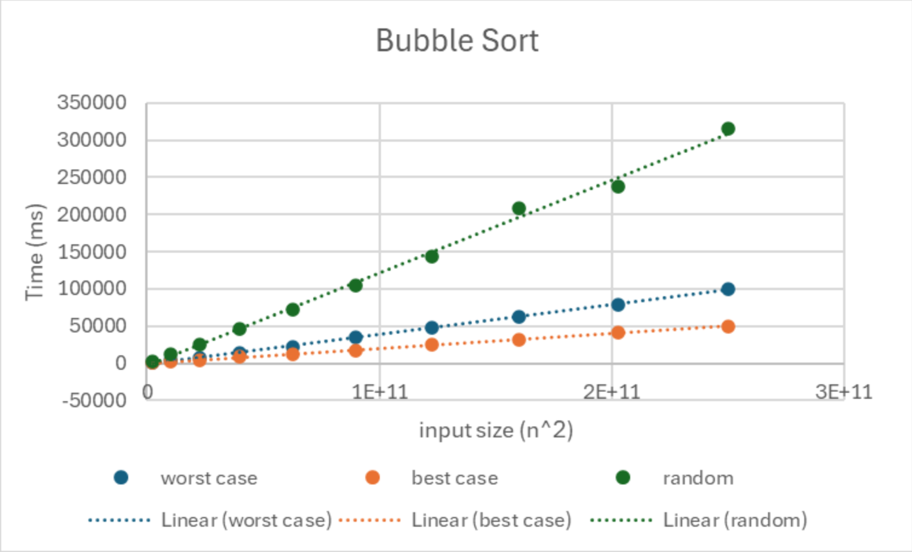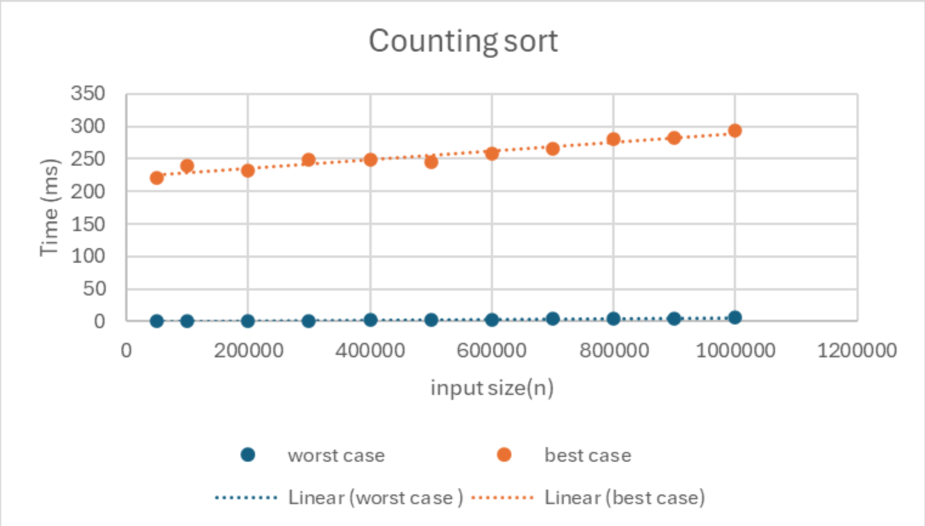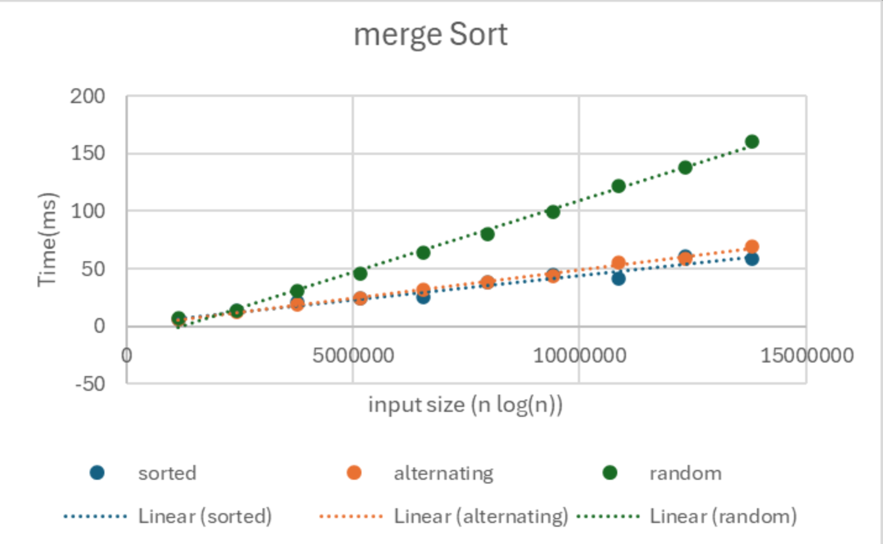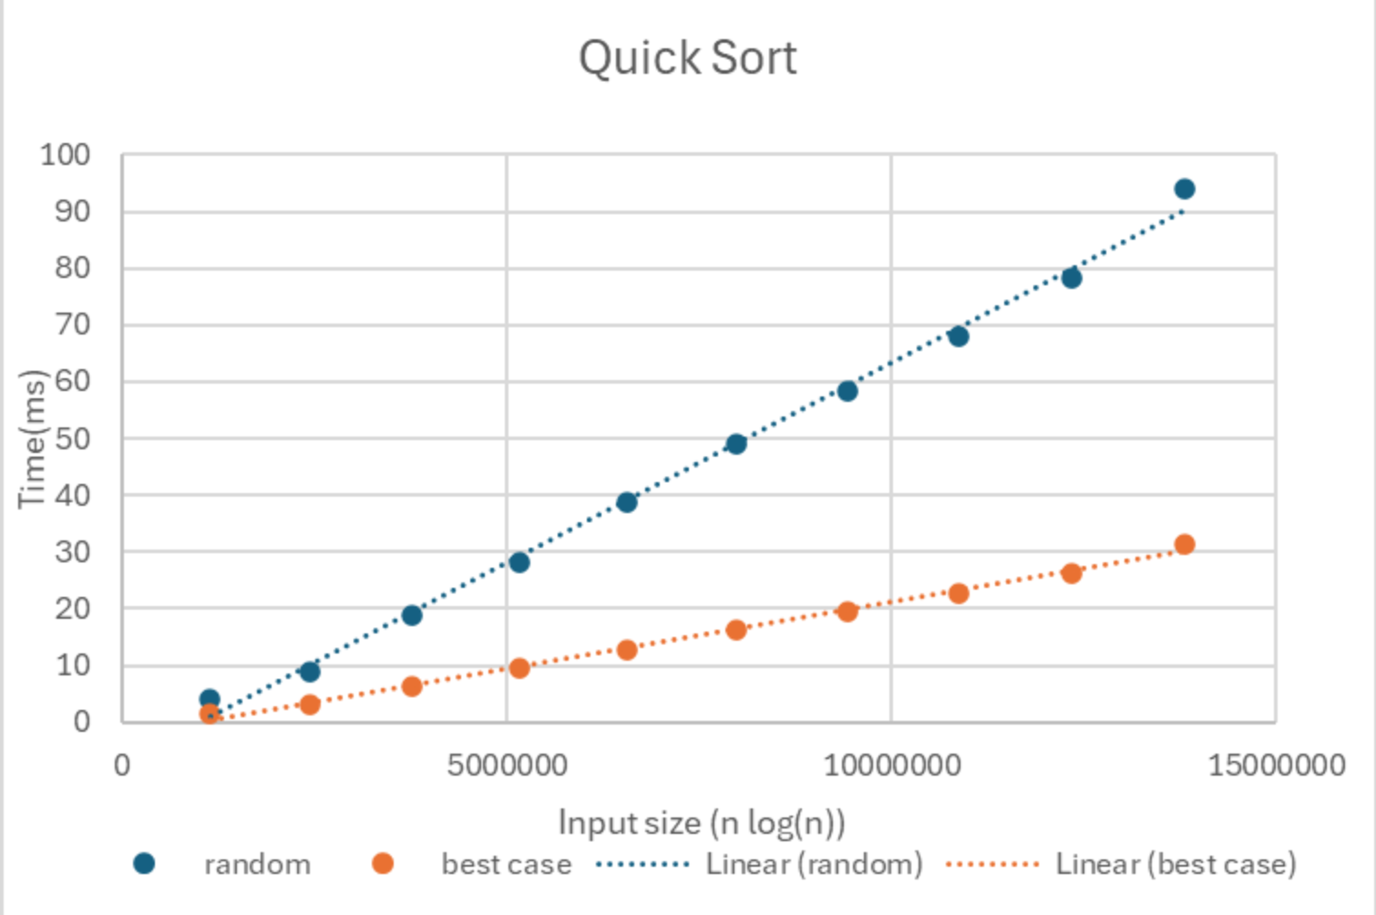
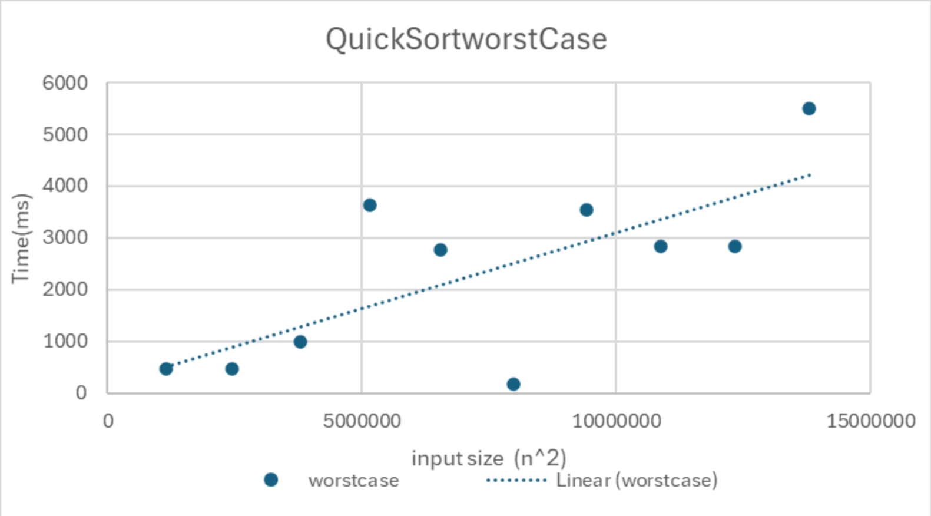

Importing & Sorting Inputs Ratio
Results & Conclusion
- From the graphs above we can see there is a direct correlation between the time complexity of an algorithm, the input size and the energy used to run the sorting algorithm.

- Bubble Sort – The least energy-efficient for larger random inputs. Its energy usage rises sharply, matching its quadratic O(n²) time complexity.

- Merge Sort & Quick Sort – Both of these are much more energy-efficient than bubble sort on bigger datasets, matching their O(n log(n)) time complexities.

- Counting Sort – Appears to use the least amount of energy out of all of the sorting algorithms previously tested when it gets even the worst-case input. This fits its near linear O(n + k) behaviour.

- Merge sort looks the most consistent across different input types while quick sort and bubble sort are more sensitive to different input types.

- Input type matters – Best case inputs usually consume less energy, while random and worst-case inputs consume more.

- These results suggest that energy consumption closely follows algorithmic time complexity. Algorithms with a lower time complexity such as counting sort, merge sort, and quick sort with random inputs are more energy efficient than bubble sort as input size increases.
Results & Conclusion
Energy Consumption Graphs

Algorithm | Case | Time Complexity | Input Type | Runs | Value Range | Input Range
Bubble Sort | Worst Case | O(n²) | Reverse-Sorted | 1 CSV x 20 | 0 - size | 25k - 500k
 | Best Case | Ω(n²) | Sorted | 1 CSV x 20 | 0 - size | 25k - 500k
 | Randomly Sorted | - | Randomly Sorted | 1 CSV x 30 | -max - +max | 50k – 500k
Merge Sort | Worst Case | O(n log(n)) | Alternating Elements | 1 CSV x 30 | 0 - size | 25k - 1 Million
 | Best Case | Ω(n log(n)) | Sorted | 1 CSV x 30 | 0 - size | 25k - 1 Million
 | Randomly Sorted | - | Randomly Sorted | 1 CSV x 30 | -max - +max | 50k – 900k
Quick Sort | Worst Case | O(n²) | Reverse Sorted | 1 CSV x 10 | 0 - size | 200k
 | Best Case | Ω(n log(n)) | Evenly-Partitioned | 1 CSV x 10 | 0 - size | 1 Million
 | Randomly Sorted | - | Randomly Sorted | 1 CSV x 10 | -max - +max | 50k – 900k
Counting Sort | Worst Case | O(n + k) | Randomly Sorted (big k) | 1 CSV x 30 | 0 – 100 Million | 25k - 1 Million
 | Best Case | Ω(n + k) | Randomly Sorted(small k) | 1 CSV x 30 | 0 - 10 | 25k - 1 Million
- This table shows the time complexity for each case of each sorting algorithm, the input types used, the number of times each .csv file is run, the value ranges and the input ranges

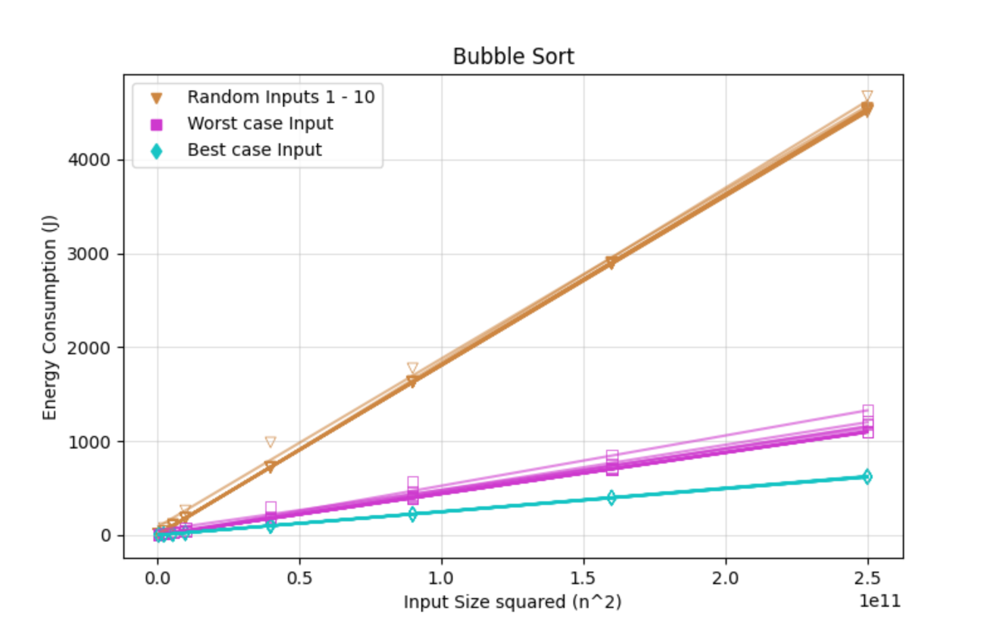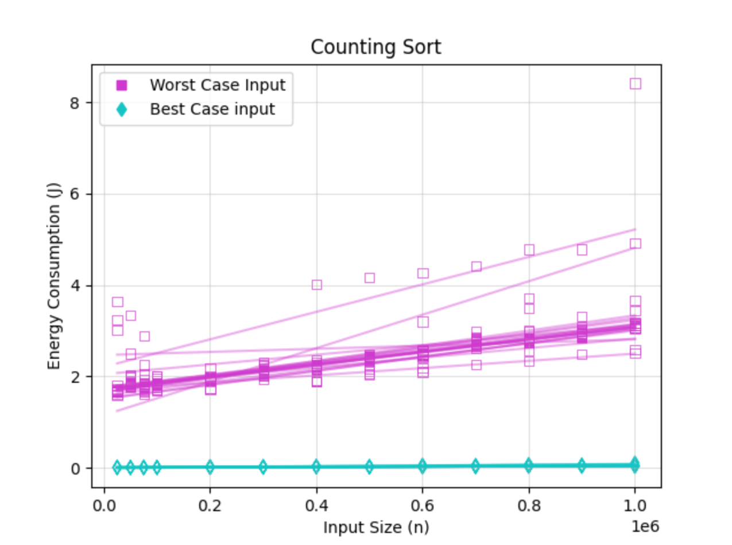
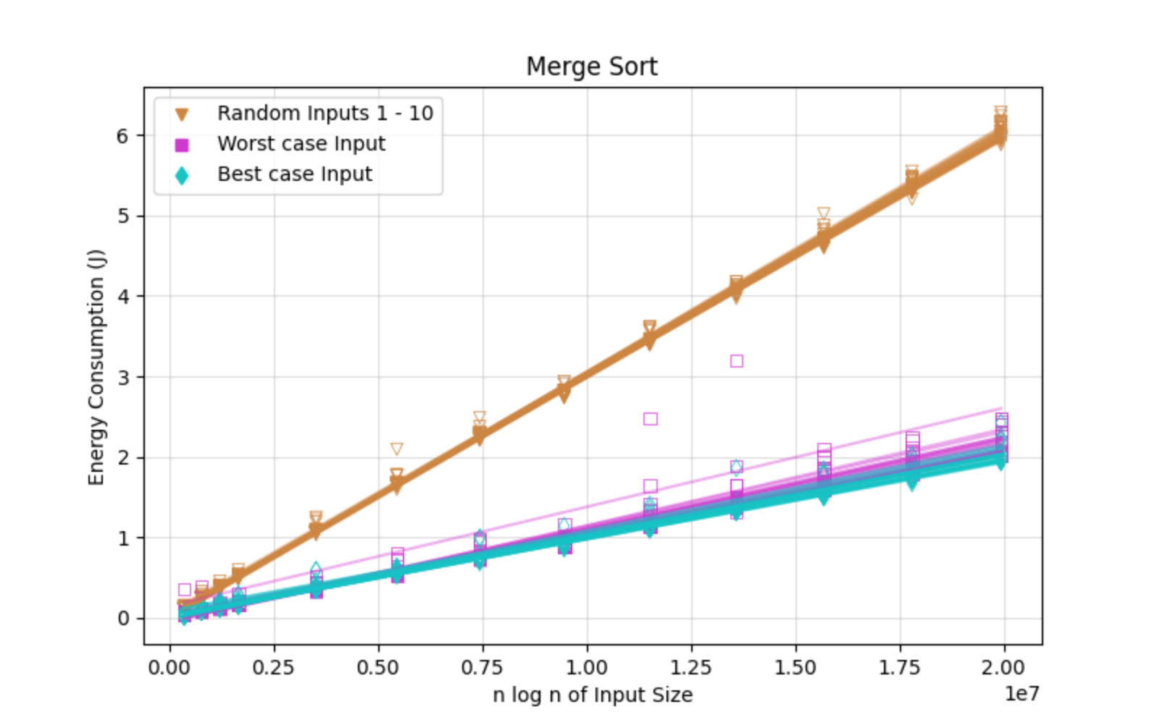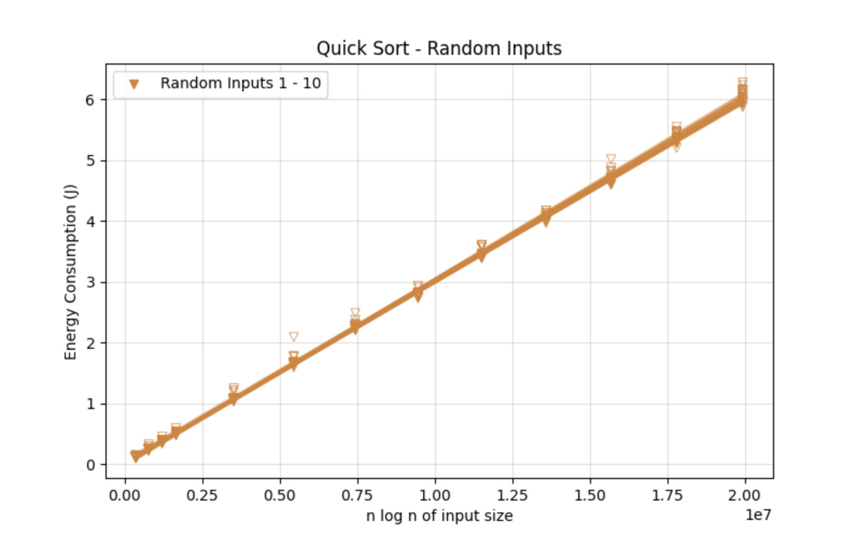
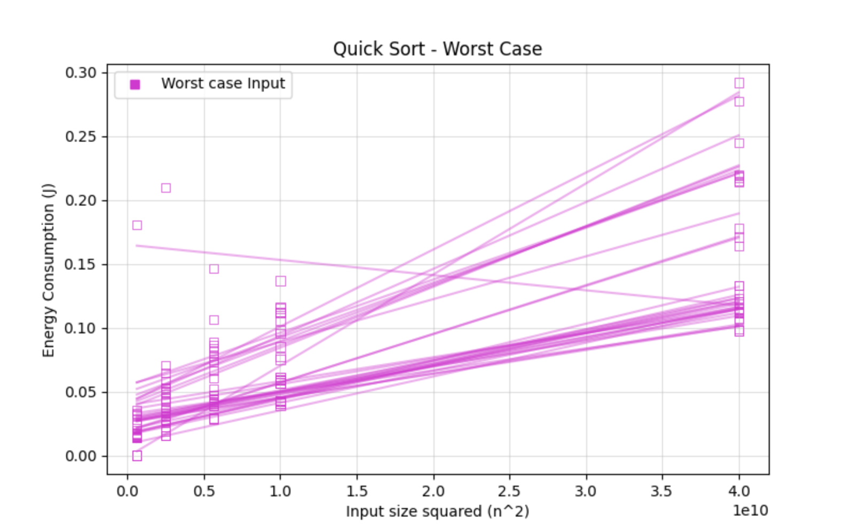

Group 7: Aleksander Ivanov, Martin McSweeney, Samuel Boyle, Sanidhya Arora
Experiments
Experiments
- Measured the energy efficiency of each sorting algorithm across best-case, worst-case, and random inputs.
- Used 10 randomly ordered CSV input files for each algorithm and input size, except Counting Sort.
- Measured CPU energy consumption using jRAPL.
- jRAPL is a java library that records the energy used while the code is running.
- Recorded energy usage in joules for every algorithm, input size and input type.
- Stored results in CSV files for analysis.
- Used the collected data to generate the graphs shown below.

